# Capacitor

A capacitor is a passive electronic component that stores electrical energy in an electric field. It acts like a temporary battery in a circuit.

**Working Principle:**  
When voltage is applied, charges accumulate on the plates of the capacitor, separated by a dielectric material. When the circuit demands, the capacitor releases this stored energy.

**Types**:  
- Ceramic Capacitor  
- Electrolytic Capacitor  
- Tantalum Capacitor  
- Film Capacitor  
- Supercapacitor

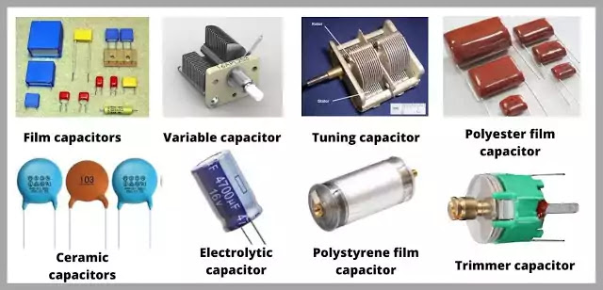

**Applications**:  
- Power supply filtering  
- Energy storage  
- Signal coupling and decoupling  
- Oscillators and timers  
- Motor starters

**Advantages**:  
- Fast charge/discharge cycle  
- No moving parts (reliable)  
- Available in a wide range of values

**Disadvantages**:  
- Limited energy storage compared to batteries  
- Polarity-sensitive (for electrolytic types)  
- Can degrade over time